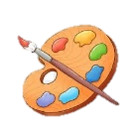
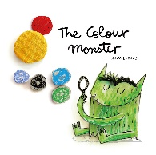
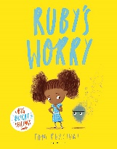
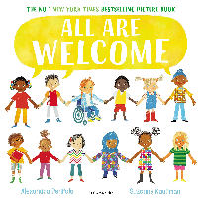


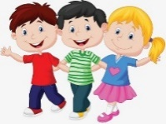


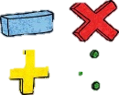




Maths

Over the coming weeks we will be focusing on sorting objects into different groups, for example colour and size. We will begin looking at the composition of numbers 1, 2, & 3 getting children confident using, recognising, matching and manipulating these numbers. We will also be looking at simple shapes, mass and capacity.

Expressive Arts and Design

We shall be thinking about ourselves and our bodies. We will be creating self-portraits and drawing our families. We will also be expressing our emotions through different forms of expression, paint, music and PE. We will explore how to -mix, change, shape and join materials and resources.
We will listen to music and say how it makes us feel. We will move in time with the pulse, and play games with high and low sounds. We will revisit familiar songs and learn new ones, and play musical instruments with control.

Communication and Language
We will be discussing different emotions and talking about how these emotions can make us feel. We will be looking at past events in our lives and describe these events in details.
We will be looking at a range of stories to develop vocabulary and knowledge. These stories include Ruby’s Worry, The Colour Monster, Leaf Man, All are Welcome.

Physical Development
This term we will be focusing on Introduction to PE Unit 1 and Fundamental Unit 2 with our sports coach Samir and his team.
Introduction to PE Unit 1—In this unit, children will be introduced to Physical Education and structured movement through the topic of 'everyday life'. They will spend time learning basic principles of a PE lesson such as safely using space, stopping safely, using and sharing equipment and working individually, with a partner and group. They will take part in activities which will develop fundamental movement skills such as running, jumping and skipping. Children will also play simple games and begin to understand and use rules.

We will also be developing our fine motor skills to help develop our hand strength. We will be completing a range of activities including threading, cutting, using tweezers, balancing small objects.

Personal, Social and Emotional Development

To start the year, we will be building new relationships with our peers and teachers. We will play lots of interactive games to build up our confidence and friendships. We will be discussing how we are similar and how we are different. We will also be having lots of discussions about different emotions and how our emotions are affected. The emotions we will look at include happy, angry, sad, upset, lonely, anxious and excited.

Phonics
To begin the year, we will be playing lots of phonics games, looking at: alliteration, rhyming, grouping sounds, initial sounds and blending sounds together. This will lead us into building words. The first ‘sounds’ we use when word building are: a,i,m,s,t,n,o,p .Get a jump start with the Sounds Write App (google sounds write app or search the app store—it is called ‘initial code’. Take at look at the phonics videos on our website for further explanation about how we teach Sounds Write.
https://www.smallberrygreen.co.uk/phonics/

Topics
To start our year in Reception our first topic will be all about them. We shall be looking at our classes, families and their life at home. -who they live with, what they like to do, where they like to visit. We shall also be thinking lots about our feelings and why and when we might feel certain emotions.

Reception Autumn Term
at Smallberry Green

