


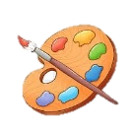




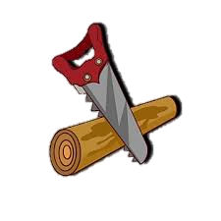
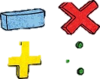





Music
We will begin preparing for the upcoming Young Voices concert where children will be performing on stage at the O2 in front of a live audience in January.

Art
Our focus this term is on illustration as we explore ways to tell stories through picture. Have a look at your books and comics at home to see how other illustrators have brought stories to life.
Key Vocabulary: illustration, mark making, medium, sequencing, graphic novel.

Science
Our topics will be: The Digestive System and Skeletons (teeth). We will be exploring the function of digestion and how enzymes and acid break down food, allowing the body to absorb vital minerals the body requires to function best. Furthermore, we will be investigating teeth drawing comparisons with carnivores and omnivores.

Geography
We will be studying the physical processes connected with rivers and the formation of river landscapes, and the interaction between physical and human environments through river flooding.
https://www.bbc.co.uk/bitesize/topics/z849q6f/articles/z7w8pg8

History
The children will be exploring the historical impact of The Romans and how their exploits have impacted Great Britain’s urban life, roads, permanent military garrisons, centralised government, taxation, their language – Latin – and later Christianity to all the lands they conquered.
https://www.bbc.co.uk/bitesize/topics/zqtf34j

PE
Children will be exploring Gymnastics, sharpening their ball skills and developing their fundamentals. Pupils will develop the fundamental skills of balancing, running, jumping, hopping and skipping. Pupils will develop their ability to change direction with balance and control.
Design Technology
We will be making textile pencil cases this term. This will involve sewing pieces of fabric together as well as designing their final product to a specific brief.
Key Vocabulary: design brief, measure, stich, join, evaluate

Year 4 Autumn Term
at Smallberry Green
English Grammar and Punctuation
We will be learning to embed adverbials and expanded noun phrases to add detail and depth, whilst using indirect and direct speech effectively in and across paragraphs. Children will also have opportunities to demonstrate appropriate choice of pronoun and noun to aid cohesion and avoid repetition.
https://www.bbc.co.uk/bitesize/subjects/zf4f8p3

RE and PSHE
We will then be thinking about how Christianity spread as a religion and what Christianity will be like in 2000 years from now.
In PSHE, we will be considering the topics, ‘Celebrating differences’ and ‘Being me in the world’. We will learn how our attitudes and actions make a difference to the class team and will explore how it feels to be valued and included.
Computing
Children will be competing two separate units this term called ‘We are Co-Authors’ where they will be creating their own wiki and ‘We are Game developers’ where they will create their own online educational game.

Maths
We will be focusing on our knowledge of place value, strengthening our understanding of formal written methods and arithmetic. https://www.bbc.co.uk/bitesize/subjects/z826n39
https://www.topmarks.co.uk/maths-games/hit-the-button

