
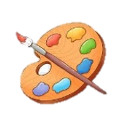
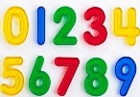
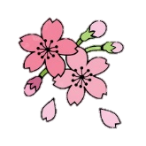
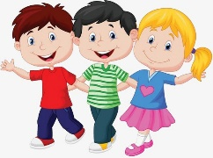
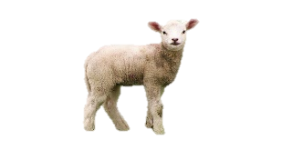



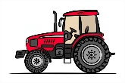


Physical Development

We will be continuing to develop our hand strength through a range of fine motor activities. We will be continuing to learn to use manipulatives with control. We will be using manipulatives such as tweezers, pegs, pipits, playdough to help us to continue to build up our hand strength.
In PE the children will be develop their expressive movement through the topic of 'everyday life'. Children will explore space and how to use space safely. They will explore travelling movements, shapes and balances. Children will choose their own actions in response to a stimulus. They are given the opportunity to copy, repeat and remember actions. They are also introduced to counting to help them keep in time with the music. They will perform to others and begin to provide simple feedback.
The children will also continue to develop their gymnastic skills, through the topic of 'animals and their habitats'. Children will explore basic movements, creating shapes, balances, jumps and begin to develop rocking and rolling. They will also show an awareness of space, and how to use it safely to perform basic skills, on both floor and apparatus. They will copy, create, remember and repeat short sequences. They will also begin to understand using levels and directions when traveling and balancing.

Expressive Arts and Design
We will revisit some familiar songs, and continue to learn new ones. We will explore high and low, loud and quiet, fast and slow. We will copy rhythms and play games with songs. We will play musical instruments with more control.
In the first half term we will be making different vehicles out of junk modelling. We will be drawing/painting different types of transport. We will also be designing our own modes of transport.
In the second half term, we will be creating a variety of animals using different media. We will also complete some cooking this half term such as bread rolls.

Maths
We will be continuing to focus on number recognition and getting the children confident in using, recognising, matching and manipulating these numbers. We will also look at positional language such as below and above.
As the term progresses, we will be learning to recite numbers to 10 correctly through a variety of fun maths activities and songs. We will also continue to look at positional language such as below, inside, above, next too. We will also categorise animals according to their colour and size.
The following website has some great interactive number games that you and your child can play together. https://www.topmarks.co.uk/Search.aspx?AgeGroup=1

Phonics
We will be continuing to play lots of phonics games whilst looking at the initial sounds. We will also continue to focus on tuning into sounds (auditory discrimination), remembering sounds (auditory memory) and talking about sounds around us (developing vocabulary). We will also begin to look at letters and the sounds they make. Use your sound books at home to practice these sounds. As the term progresses, we will consolidate the letter sounds we have looked at, getting really confident using these. (m a, i, s, t).
We will then continue with the sound: n, o, p, d

Topic
Our first topic will be transport. We will be exploring the different types of transport we use on water, land and air. We will be discussing when we would use them, where would we go and who would use them. We will also be reading different stories and learning different songs, based on travelling and transport. Our second topic will be down on the farm. We will be exploring the different types of animals we see on a farm and what they provide us with. For example, a cow provides us with milk and beef. We will be discussing our experiences of going to a farm. We will also be reading different stories and learning different songs based on our topics.

Nursery Spring Term
at Smallberry Green
Communication and Language

We will be having lots of discussions about the different types of transport (land, air and water) we see and use. We will also be reading stories and singing songs about travelling and transport.
Vocab: transport, vehicle, wheel, axel, car, bus, train, bike, aeroplane, boat, tram, submarine, hot air balloon, coach, tractor, ship
As we move into Spring 2, the children will be looking at a variety of different animals and sorting them into groups. We will focus on animals we can find on a farm and the noises each animal makes. We will also be singing a variety of songs such as Old Mac Donald, 5 Little Ducks, Come to our animal tea party and Driving my Tractor.

Personal, Social and Emotional Development
We will be reading the story ‘Farmer Duck’ and discussing how the animals were kind and helpful to the duck. We will be talking about how we can be kind and helpful both at nursery and at home.
We will be continuing to have lots of discussions and working around different emotions and how our emotions are affected.
We will be playing lots of turn taking games such as Pop-Up Pirate to continue to develop sharing and turn taking skills.

