Personal, Social and Emotional Development
We will learn about what makes a healthy person. The children will explore healthy eating, exercise, and the importance of keeping clean. We will talk about why we need to wash our hands, brush our teeth, and get enough sleep to help us feel our best and be ready for school.
Later in the term, we will discuss the importance of being resilient, even when things are tricky. The children will understand that by persevering, they can overcome challenges and achieve their goals.

Communication and Language
The children will be learning key vocabulary linked to different jobs and the equipment people use to help us — for example, syringe, fire hose, handcuffs. We will be having some special visitors in to talk about how they help us and the children will haver the opportunity to ask questions.
We will be looking at a selection of books including, The Gruffalo, We are Going On A Bear Hunt, The Tiger Who Comes To Tea and The Smartest Giant in Town. We will be using repetitive language to retell the stories and learn new vocabulary.
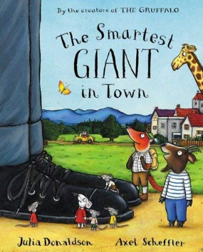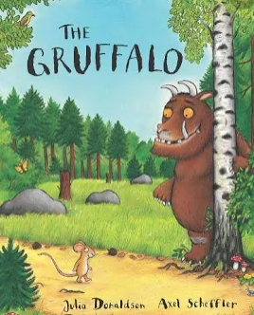

.

Topics
This term, we will be learning about the people who help us in our community and closer to home. We will talk about the important jobs they do and how they make a difference in our everyday lives. Our next topic will be Jump into a Story. We will explore popular stories and the art of storytelling. The children will learn how stories are structured with a beginning, middle, and end. We will also find out about different authors and illustrators and learn about the important roles they play in creating the books we love.



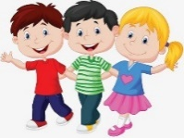
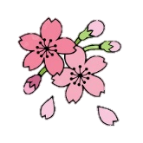

Reception Spring Term
at Smallberry Green
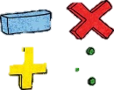
Maths
We will continue learning about numbers 0–10 and how to represent them in different ways. We will explore how each number can be made using number bonds and use resources such as counters, cubes, and part–part–whole models to help us. We will also learn to compare numbers using the words more than, less than, and the same as. The children will compare amounts and objects by size, length, height, and capacity. As we grow more confident, we will begin to work with numbers up to 20, matching numerals to groups and counting objects arranged in different ways. We will also start to estimate, compare amounts, and solve simple addition and subtraction problems.

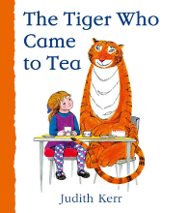
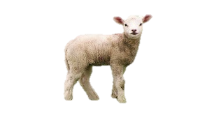

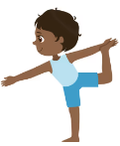
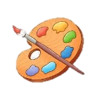
Physical Development
The children will explore travelling movements, shapes and balances. They will choose their own actions in response to a stimulus and given the opportunity to copy, repeat and remember actions. They are introduced to counting to help them keep in time with the music. They perform to others and begin to provide simple feedback. We will also continue to improve our fine motor skills so that we can continue o hold a pencil and form our letters correctly.

Phonics
This term, we will be consolidating the sounds we learnt last term and using them to build longer and more complex words such as crab, grub, swim, plug, and swill. We will also be introduced to digraphs — two letters that make one sound. These include ss, ff, ll, and zz. Once the children are confident in using these digraphs to segment and blend words, we will move on to new sounds such as sh, ch, ck, ng, qu, wh, and th.

Expressive Arts and Design
This half term, we will be learning about special celebrations such as Chinese New Year and Easter. We will create beautiful lanterns as we explore the story of the Chinese Zodiac, and will participate in a variety of fun Easter crafts. We will also be designing and making models of fire engines and painting pictures of people who help us in our community.

