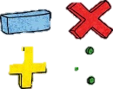




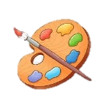



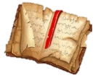
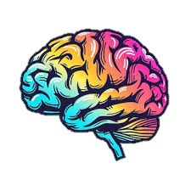
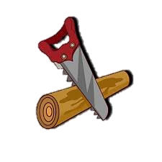



Maths
Children will be exploring the place value of numbers to 20. They will learn to represent, order and compare numbers. Children will also build upon their knowledge of addition and subtraction. To develop their understanding of these concepts, children will continue to use part whole models, ten frames, number lines and concrete objects.
English Grammar and Punctuation
Children will be taught to use capital letters, finger spaces and full stops to write cohesive sentences. They will learn to sequence sentences in order to create short narratives.
PE
Children will be exploring Ball Skills & Sending and Receiving. Pupils will develop their fundamental ball skills such as throwing, catching, rolling, hitting a target, dribbling with both hands and feet and kicking a ball. They will also use equipment to send and receive a ball, applying their skills individually, in pairs and in small groups and begin to organise and self-manage their own activities.

RE and PSHE
In Christianity, we will be finding out about acts of worship, ceremonies at church and important signs and symbols.
In PSHE, we will be considering the topics, ‘Celebrating differences’ and ‘Being me in the world’. We will explore what we need to feel safe and special in our class and how we can make it a safe place for everyone to learn. Finally, we will be taught to observe the choices we make and will understand that choices can lead to consequences.
Key Vocabulary: Similarity, Difference, Bullying, Deliberate, Unfair, Included, Celebrations, Special, Unique.

Design Technology
We will be learning to design, make and evaluate a healthy drink while exploring where a range of fruit and vegetables come from.

Computing
Bee-Bots: pupils will be introduced to algorithms as a set of step-by-step instructions given to a device, will learn how to debug simple algorithms and how to use logical reasoning to predict how a program will behave.

Music
A1: We will listen to music in the style of hip-hop and learn about its features.
A2: We will use Jolly Music to continue to develop the skills of pitch, pulse and rhythm by singing songs and playing games together.

Art
Spirals: In this unit children are enabled to build an understanding about the way they can make marks on a drawing surface. They will explore how the way they hold a drawing tool, and move their bodies, will affect the drawings they make.

Science
A1: Seasonal Changes -children will learn to name and order the four seasons as well as the weather associated with these seasons.
A2: Children will explore materials focusing on wood, plastic, glass and metal objects. They will explore simple similarities and differences between materials.

Geography
The World and Me: children will name and locate the countries that make up the UK and their capital cities on a map. They will then learn to name and locate the 7 continents and 5 oceans of the world on a map. Children will also explore compass points while developing their understanding of reading maps.

History
Children will be travelling back in time to learn about the historical figure, Guy Fawkes and the Gunpowder Plot.
Key Vocabulary
Guy Fawkes, King James I, gunpowder, Houses of Parliament, conspirators, guard, bonfire
https://www.bbc.co.uk/bitesize/articles/z6qhtrd

Year 1 Spring Term
at Smallberry Green

