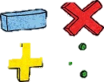
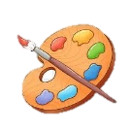



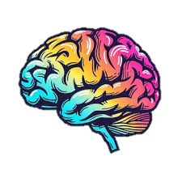
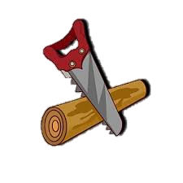

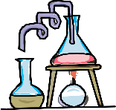

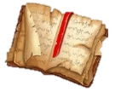




Maths
We will be perfecting our number bonds from 1-20, to enable children to successfully answer questions from 1-100. Children will also be looking at number sequences using addition and subtraction to identify missing numbers. Moreover, pupils will be strengthening their understanding of division by using strategies like grouping and sharing.
https://www.bbc.co.uk/bitesize/subjects/zqpqfdm
English Grammar and Punctuation
We will be having a go at writing our own non- fiction explanation texts

Year 2 Spring Term
at Smallberry Green
RE and PSHE
In Humanism, we will be focusing onhow we remember people as well as how our choices as humans affect others and how we can make a moral choice. We will then move on Islam and discussing topics such as ‘What is the significance of the Hijab?’ and why there are rules around food and drink.
In PSHE, we will be considering the topics ‘Dreams and Goals’ and how we can set realistic goals in life and how we go about achieving them. We will then discuss ‘making healthy choices’ linking in well with our DT and science topics.
PE
Children will be exploring Gymnastics & Invasion Games. Pupils will develop gymnastic skills of jumping, rolling, balancing and travelling individually and in combination to create short sequences and movement phrases. Additionally, Pupils will also develop the principles of defending and attacking.
Art
We will be exploring the world through ‘monoprint’. We will explore different ways to make uniquely designed prints and look closely at the work of Xgaoc’o X’are and Leonardo DiVinci.
https://www.kalkbaymodern.co.za/xgaoco-xare-qhaqhoo
Design Technology
We will be exploring healthy food, learning basic food hygiene and developing the skills needed to make our own healthy wrap.
Computing
We will be learning how to create Robot algorithms, how to make it move and complete instructions. We will then move on to creating and using pictograms.

Music
We will learn about popular music from South Africa, listening to and identifying its features. We will learn to sing a song in the style of Afropop, using glockenspiels to play melodies.
https://www.bbc.co.uk/teach/bring-the-noise/articles/z4sq92p

Science
S1: We will be exploring microhabitats and the animals we find in them.
S2: we will be learning about lifecycles and health. We will look at what our body needs to stay healthy and how we keep ourselves alive and well.
https://www.bbc.co.uk/bitesize/topics/zfg8mp3/watch/z6wmxyc

History
We will be going back in time to the 1800s and the
era of Florence Nightingale as we find about what she did and the effect she had on soldiers as well as our healthcare today. We will embark on a trip to the Florence Nightingale Museum to meet the lady herself (an actress of course!).
https://www.bbc.co.uk/bitesize/articles/znsct39
Geography
We will be investigating our street here at Smallberry Green. We will collect and analyse data of Turnpike Way as well as develop our fieldwork skills.

