


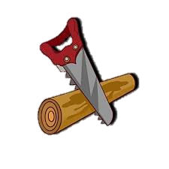

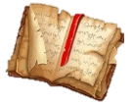
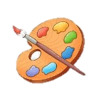


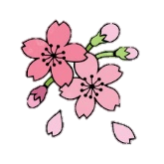
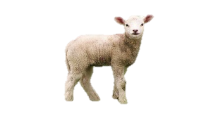

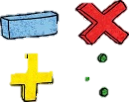



Music
We will learn about the musical style of Reggae. We will listen to lots of different examples, and explore how reggae music can be identified. We will learn about a range of artists who have produced reggae music. We will also take our first steps in learning our musical instrument, the ukulele. We will learn the names of the parts, how to hold the instrument correctly, and we will begin to learn out first chords.
Vocabulary: Introduction, verse, chorus, bass, drums, electric guitar, keyboard, organ, backing vocals, pulse, rhythm, pitch, tempo, dynamics, texture structure, compose, improvise, hook, riff, melody, reggae, ukulele, chord.
Spring 2
We will continue to develop our ability to work with the pitches so and mi. We will practise working with rhythm and pulse, and begin to use stick notation to write down our ideas. We will explore faster, slower, and keeping a steady beat. We will also continue to learn chords and develop our skills in playing our ukuleles.
Vocabulary: Rhythm, pitch, pulse, beat, tempo, faster, slower, higher, lower, stick notation, crotchet, quaver, ukulele, chord.

Vocabulary:
Art

Science
Soil, food waste and sustainability: We will explore different types of soil and what they are made up of. We will explore different types of soil, such as sandy, clay, peat and chalky soils.
Light: We will learn about sources of light. In this step, children explore the difference between natural and artificial sources of light.

RE and PSHE
RE:
Key Vocabulary: Karma, Atman, reincarnation, moksha
PSHE:

PE

Design Technology

Computing

History
Shang Dynasty:

Geography
Mountains and volcanoes:
https://www.bbc.co.uk/bitesize/articles/z3qthcw#zs88wnb

Year 3 Spring Term
at Smallberry Green
English Grammar and Punctuation
Children will be taught to express time, place and cause by using adverbs, conjunctions and prepositions to add detail and aid cohesion. Lastly, children will be learning how to use both directed and reported speech effectively.
https://www.bbc.co.uk/bitesize/topics/zk7cmbk
Maths
Following our mastery approach, children will be learning how to multiply and divide numbers by 10, 100 and 1000; whilst strengthening their technique of formal written methods of division. Children will be revising their times tables as part of the Multiplication Check.
https://www.topmarks.co.uk/maths-games/hit-the-button

