

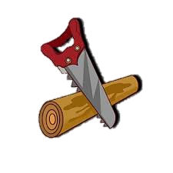

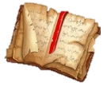
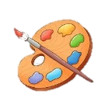

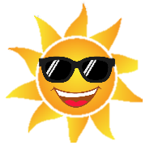
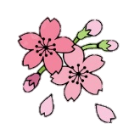
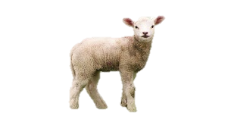


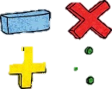

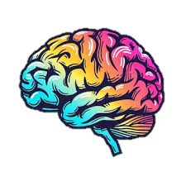

PE
Basketball: Children will be developing their understanding of tactics whilst enhancing their dribbling and throwing skills.
Rugby: Pupils will be encouraged to think about how to use skills, strategies to outwit the opposition. They’ll develop their understanding of the importance of fair play and honesty while self-managing games, evaluating their own and others’ performances.
Swimming: weekly sessions will continue as children learn varying techniques and learn about water safety.

RE and PSHE
RE: Sikhism – we will be exploring identity and how what you wear impacts your beliefs. Pupils will learn about the significance of the 5 Ks.
Key Vocabulary: Khalsa, Dastar Bandi, identity, khanga and Kara.
PSHE: Dream & Goals and Healthy Me: Children will be exploring the power of assertiveness, peer pressure and harmful affects of smoking and alcohol.

Design Technology
Our topic is called: Making Pencil Cases. Children will be learning how to sew effectively, cutting patterns out of fabric to stitch materials together.

Computing
Repetition & Shapes: Learners will create programs by planning, modifying, and testing commands to create shapes and patterns. They will use Logo, a text-based programming language.

History
Ancient Egyptians: Children will be looking at what sources of evidence have survived and how they have been discovered to learn more about this civilization. We will also be exploring the afterlife and Egyptian culture, considering its historical impact. https://www.bbc.co.uk/bitesize/topics/zhkydnb

Geography
Europe: Children will be exploring the EU, its countries and the exchange rate. What’s more, they will be exploring the varying landscapes and coasts and how these will have an impact on tourism. Children will also be investigating whether continents can have shared and individual identities.
https://www.bbc.co.uk/bitesize/articles/z3qthcw#zs88wnb

Art
Still Life: Pupils will develop skills in learning to see, mark making, using various media, exploring line and colour, relationships between 2d and 3d shape, light and dark (tone).

Science
S1: States of Matter - Children will be investigating the properties of solids, liquids & gases whilst explaining the effects of the Water Cycle.
S2: Sound and vibrations – Children will be able to explain the relationship between vibration, strength and volume. They will also be able to describe both the relationship between volume and distance and explain how insulating materials can be used to muffle sound.
https://www.bbc.co.uk/bitesize/topics/zrxktcw

Year 4 Spring Term
at Smallberry Green
Music
We will continue to prepare for our upcoming concert at Young Voices, enabling us to develop our skills in matching pitch, and singing songs in more than one part. We will then begin our learning about The Beatles, listening to examples of their songs and identifying what is distinctive about their music.
Vocabulary: Acoustic guitar, percussion, birdsong, civil rights, racism, equality, pentatonic scale.
English Grammar and Punctuation
Children will be taught embed fronted adverbials to add detail and up-level sentences. They will also explore the use of apostrophes to show contraction and possession. Lastly, children will be strengthening their cohesion by interchangeably using noun and pronouns.
https://www.bbc.co.uk/bitesize/topics/zktdp9q

Maths
Following our mastery approach, children will be learning how to multiply and divide numbers by 10, 100 and 1000; whilst strengthening their technique of formal written methods of division. Children will be revising their times tables as part of the Multiplication Check.
https://www.topmarks.co.uk/maths-games/hit-the-button

