


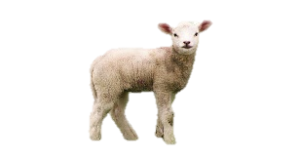
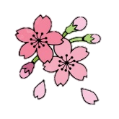

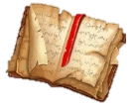
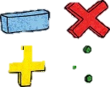






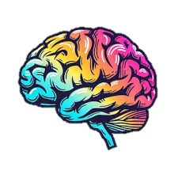

Science
S1: Earth & Space - children will be learning about the heliocentric model of our solar system and will be investigating the effects of gravity and identifying the characteristics of our planets.
S2: Life Cycles and Reproduction – children will be able to describe the stages of an amphibian, mammal, bird and explain the asexual reproduction of plants.
https://www.bbc.co.uk/bitesize/topics/z8vxb7h

PE
S1: Dance - Pupils will focus on developing an idea or theme into dance choreography. They will work in pairs and groups using different choreographing tools to create dances e.g. formations, timing, dynamics.
S2: Badminton - Pupils focus on developing the skills they need to play continuous rallies in badminton. They will learn about the ready position, racket control, serving and hitting over a net and how to use these skills to make the game difficult for their opponent.

Year 5 Spring Term
at Smallberry Green
Music
S1: Hip-pop unit of The Fresh Prince of Bel-Air. We will listen to and appraise lots of examples of the genre by a range of artists, and practise sharing our opinions and commenting on music elements, whilst learning the recorder.
S2: We will learn Madina Tun Nabi, a Nasheed (Islamic Song) with a chorus in two parts. We will learn to sing the song, develop our own accompaniment with a drone, chords, and improvisation, and play together with a percussion backing track.
Design Technology
Our topic is called: cooking and nutrition. Children will be creating their own pizza and exploring food hygiene and flavour profiles.

Computing
Physical Computing: learners will explore the concept of selection in programming through the use of the Crumble programming environment. Learners will be introduced to a microcontroller (Crumble controller) and learn how to connect and program it to control components.

English Grammar and Punctuation
Children will be taught embed relative clauses and parenthesis in the writing to add detail and avoid ambiguity. Children will also be learning about modal verbs and how they can be used to create possibility.
https://www.bbc.co.uk/bitesize/topics/z4nqfdm
Maths
Following our mastery approach, children will be perfecting their understanding of short division and knowledge of long multiplication to increase their fluency. They will also be investigating area and perimeter applying their knowledge of the operations. Lastly, they will be learning to order and compare, add and subtract fractions effectively.
Art
Typography & Maps: Children will be creating sketches to record their observations and use them to review and revisit ideas. They will research great artists, architects and designers in history to create their own map, arranging letters to create a visual art piece.

Geography
Major Cities: Children will be exploring the capital city, London, dissecting its infrastructure, sustainability and how the weather and climate effect tourism.
https://www.bbc.co.uk/bitesize/articles/z3qthcw#zs88wnb

History
Benin Kingdom: Children will be exploring the civilization and analysing sources to investigate its secrets of natural resources and wealth. Pupils will also learn what the kingdom has given us today and its wider influence.
https://www.bbc.co.uk/bitesize/topics/zpvckqt

RE and PSHE
RE: Sikhism – we will be investigating the concept of seva and its influence within the community.
Key Vocabulary: Dhan, man, Vand Chakkho, equality & Grur Granth Sahib.
PSHE: Dream & Goals and Healthy Me – Pupils will be setting goals for themselves and considering careers which make a real difference. Children will be discussing and evaluating the effects of drugs, exploitation and taking personal responsibility.

