
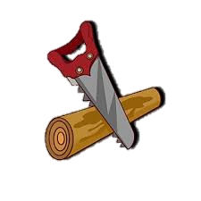



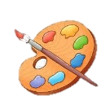

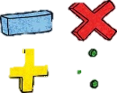



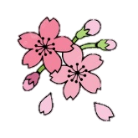

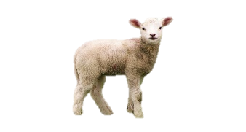
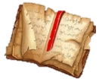
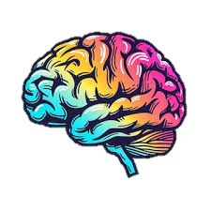
Computing
Variables in Games: unit explores the concept of variables in programming through games in Scratch.
Introduction to Spreadsheets: unit explores useful life skills of databases and how they work.
Design Technology
Our topic is called: mechanical systems. Children will be conducting research on fairground rides as they learn to create their own lever and pulley systems to create a ride which has a functioning motor.

PE
S1: Dance - Pupils will develop an idea or theme into dance choreography. They will create different choreographing tools to create dances e.g. formations, timing, dynamics.
S2: Rugby - pupils will develop key principles (defending, attacking, throwing, catching, running and dodging). When attacking, pupils will support the ball carrier using width and drawing defence. When defending, pupils learn how to tag, track and slow down an opponent, working as a defensive unit.

Maths
Children will be extending their understanding of shape by measuring angles and calculating area and volume. Additionally, they will be using their knowledge of the four operations to work out missing values in simple algebraic equations. Revision of all areas of the maths curriculum will be consistently reviewed to prepare children for their SATs tests.
Science
S1: Circulation and Health - children will learn to understand how the heart pumps blood around the body to deliver oxygen and key nutrients to every cell. They will also take part in a heart dissection, bringing their learning to life.
S2: Evolution and Inheritance – children will be able to define and identify variation in organisms and recall what is caused by inherited and environmental factors.

Geography
World Trade: children will understand the difference between a developing and first world country and make connections with import and export and how organisations can influence economic markets.
https://www.bbc.co.uk/bitesize/articles/zk4rmfr#zdpthcw

History
Children will be exploring William Hogarth and his depictions of social decay, crime and political corruption.
Key Vocabulary: satire, printing, society, politics, social decay, reliability, interpretation.

RE and PSHE
RE: Sikhism and Islam - We will be exploring the theme of sacrifice and the festival of Vaisakhi Sikhism and what it means for the believers and the importance of prayer in Islam.
Key Vocabulary: Khalsa, Amrit, Guru Gobind & Panj Pyare.
PSHE: Personal Goals and Responsibility - We will talk about different types of drugs and the effects these can have on people’s bodies. We will discuss exploitation as well as gang culture and the associated risks.

Music
We will explore Gustav Holst’s The Planets, identifying how different moods can be created through music, and learn about ostinato, crescendo and diminuendo. We will compose, perform and evaluate our own musical soundscapes inspired by the music we have heard, exploring how to combine sounds and use dynamics within our own work.

Art
Exploring identity: Pupils should be taught to develop their techniques, including their control and their use of materials, with creativity, experimentation and an increasing awareness of sketching and collage to produce artwork that best represents themselves.

English Grammar and Punctuation
Children will be taught to use literary devices to aid imagery and enhance their knowledge of organizational features as part of writing an explanation text on The Circulatory System. Revision of word classes, punctuation and all areas of grammar will be consistently practiced for upcoming SATs tests.
https://www.bbc.co.uk/bitesize/topics/zwwp8mn
Year 6 Spring Term
at Smallberry Green

